Physics Bridging task.

Preparation for a Maths test. This will take place in the second lesson of your timetable in year 12. From this we will assess who needs further support with essential maths skills. Will you be the first person to get 100%?

Please submit this support document in your first lesson.

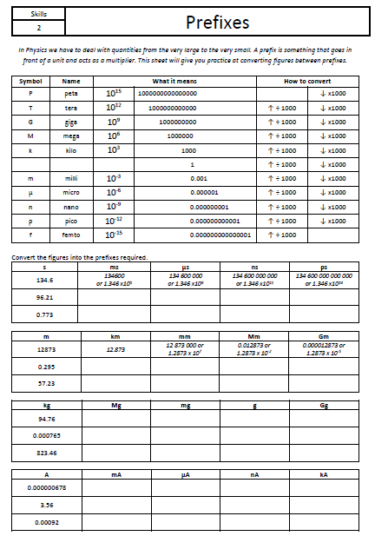

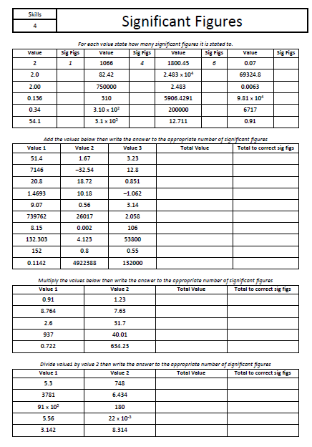

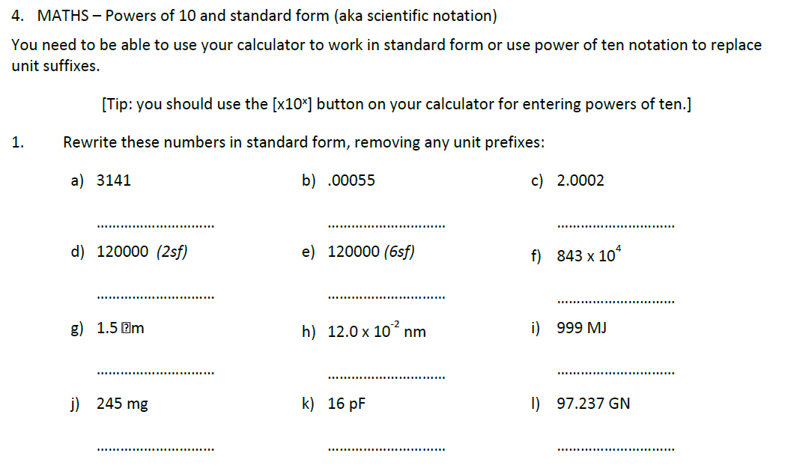

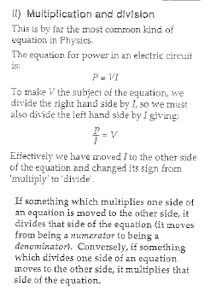Changing the subject of an equation.

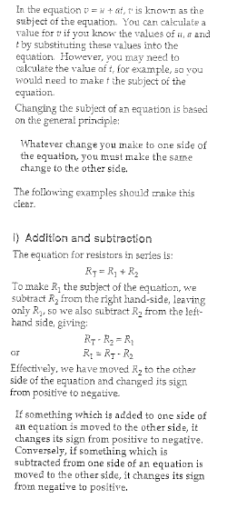

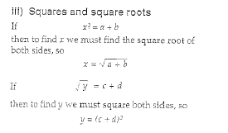

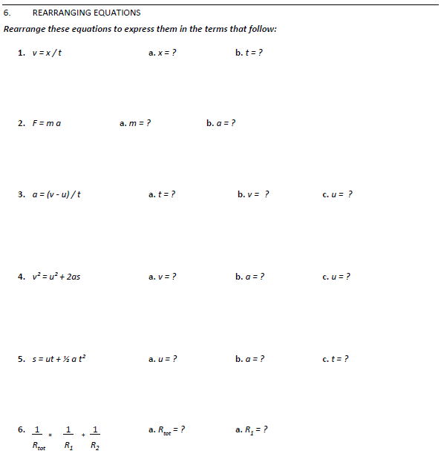

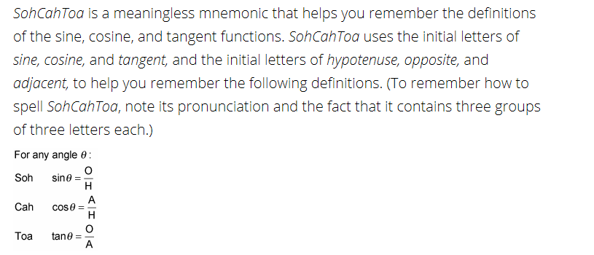Trigonometry.

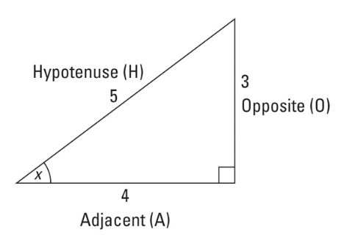

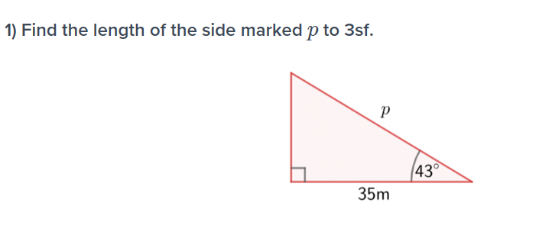

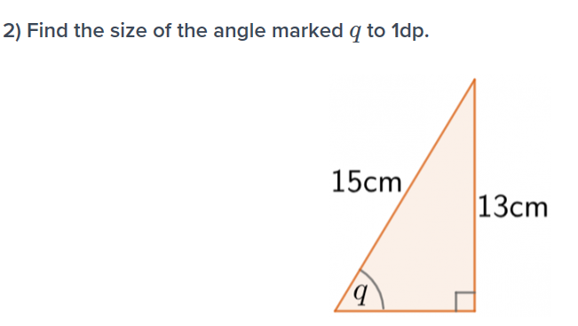

Cross-sectional areas.

Write the formula to find the area of

1. A Triangle
2. A circle.

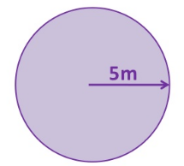Find the area of Find the cross sectional area of

1. [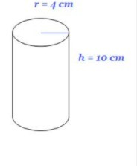](https://www.google.co.uk/url?sa=i&rct=j&q=&esrc=s&source=images&cd=&cad=rja&uact=8&ved=2ahUKEwiC79bu4J3iAhVUBGMBHQlSB7gQjRx6BAgBEAU&url=https%3A%2F%2Fbrainly.com%2Fquestion%2F9417208&psig=AOvVaw3WlEpt64iO1dmEg_AdKDiT&ust=1558017295717635) a.

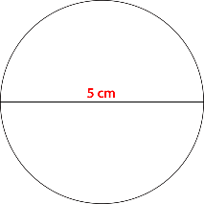2.

3.

b. [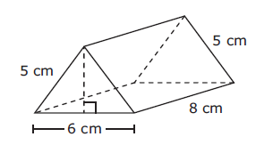](https://app.wizer.me/preview/5YF92M)

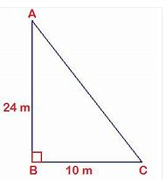

4.

[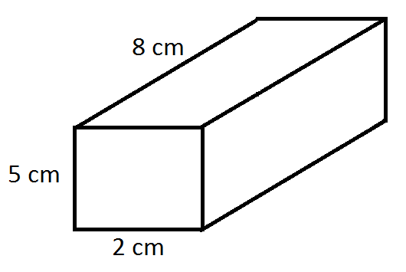](https://www.google.co.uk/url?sa=i&rct=j&q=&esrc=s&source=images&cd=&cad=rja&uact=8&ved=2ahUKEwjptpan4Z3iAhWF3eAKHQD-D_QQjRx6BAgBEAU&url=https%3A%2F%2Fbakhmalamath9.wordpress.com%2Fvolume-of-three-dimensional-figures%2F&psig=AOvVaw1WCoaapLzO1rkb_g1bmGRO&ust=1558017386545718) c