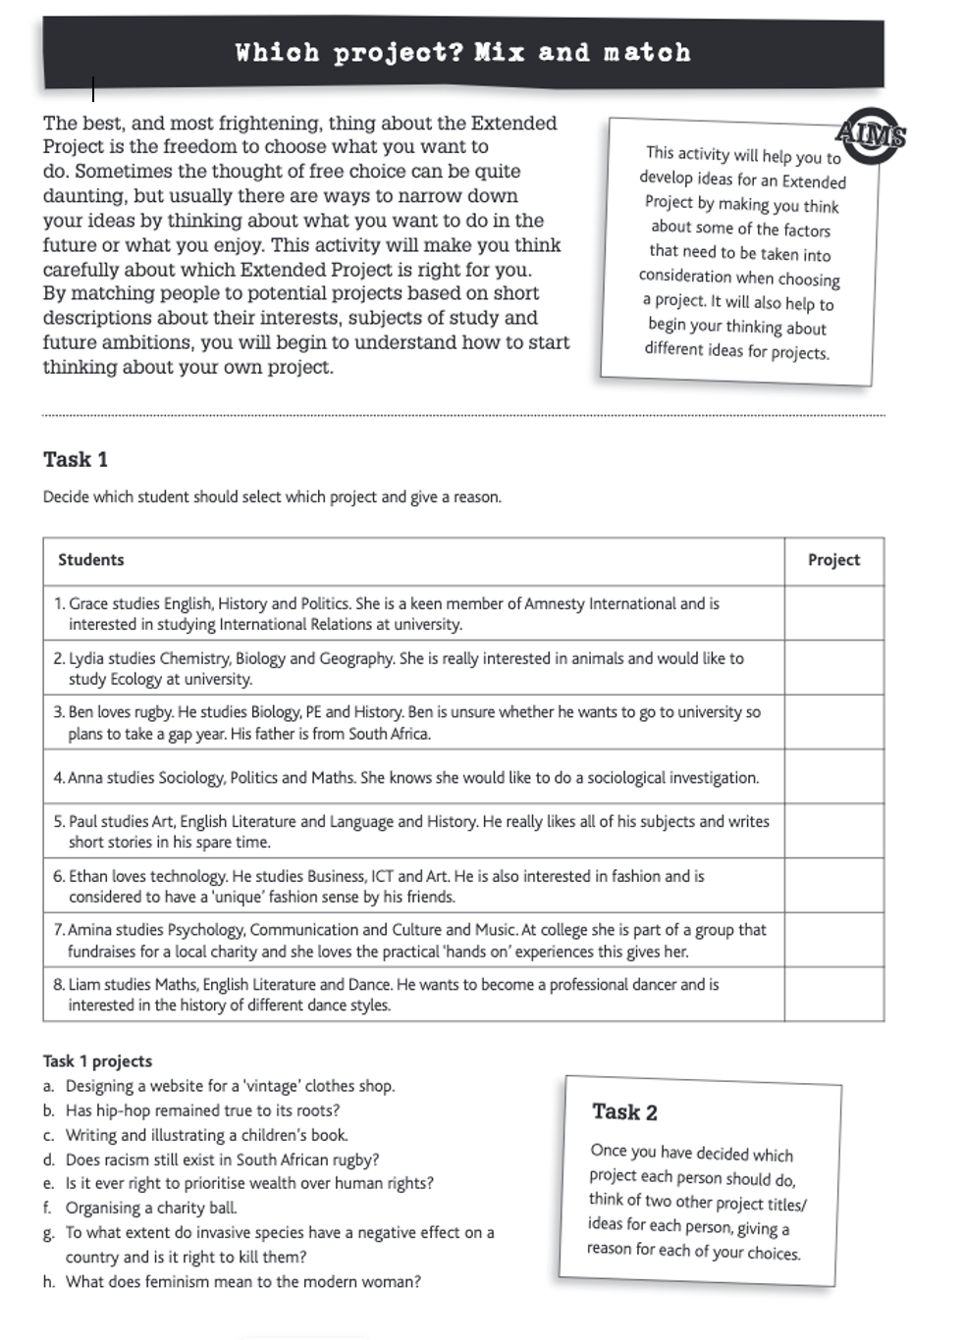

Don’t forget to include a reason for your decisions.

TASK 2 | Project one (chosen from list below)
 | Title:
What format? (essay, investigation/scientific research report, artefact/exhibition, performance…..event (give reasons)
Improve Title:
Clearer focus, allow for more extended work, analysis and synthesis of different ideas and perspectives and clearer arguments for and against a proposition…..
Aims & Objectives for project: what specifically would you want to achieve in studying this topic for your EPQ
A list of the Research issues / topics you might need to complete this project
Is this project: Safe (consider potential hazards) Practical (Think about resources and facilities) Ethical (Might it cause distress and how would you respect people’s privacy) Accessible (think about the availability of research material)
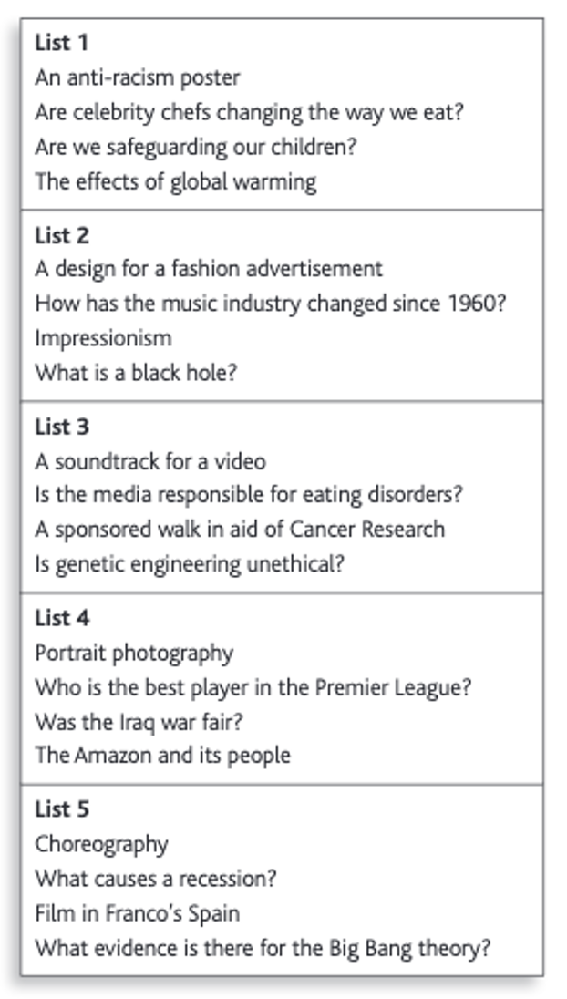

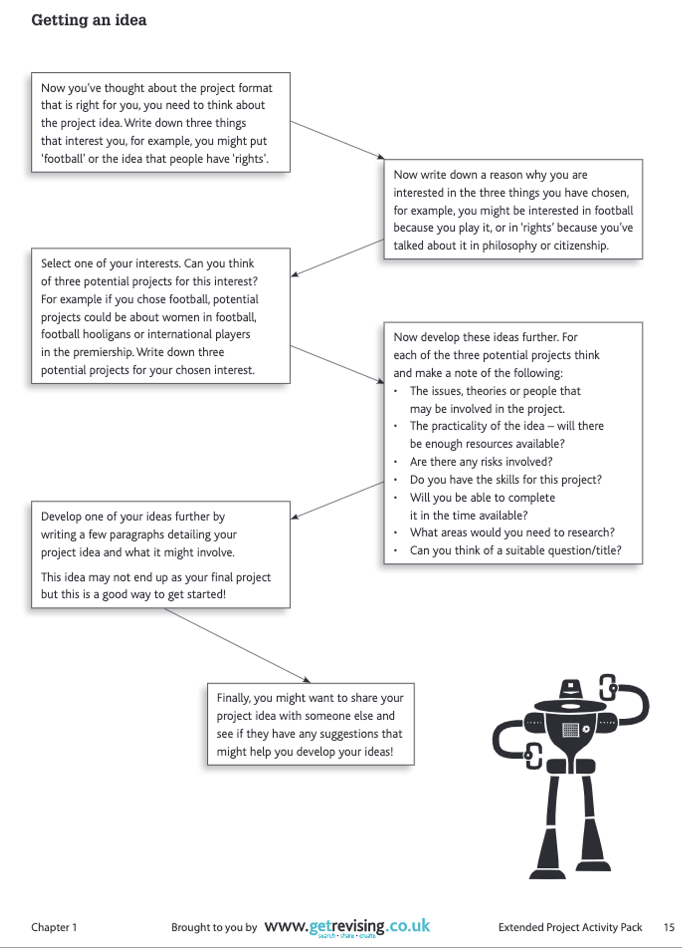
TASK 3 (a)

TASK 3 (b) | Project TWO (Your first topic idea)
 | Title:
What format? (essay, investigation/scientific research report, artefact/exhibition, performance…..event (give reasons)
Improve Title:
Clearer focus, allow for more extended work, analysis and synthesis of different ideas and perspectives and clearer arguments for and against a proposition…..
Aims & Objectives for project: what specifically would you want to achieve in studying this topic for your EPQ
A list of the Research issues / topics you might need to complete this project
Is this project: Safe (consider potential hazards) Practical (Think about resources and facilities) Ethical (Might it cause distress and how would you respect people’s privacy) Accessible (think about the availability of research material)

