Psychology A Level Year 12
Research Methods
Glossary Task:
Create a glossary of the following terms. Keep this in the back of your folder.
Experimental Hypothesis
Directional Hypothesis
Non-directional Hypothesis
Lab experiment
Field Experiment
Quasi Experiment
Independent Measure Design
Repeated Measures Design
Matched-Pairs Design
Internal Validity
External Validity
Ecological Validity
Application Task:
Read the information about the following experiment and answer the questions that follow
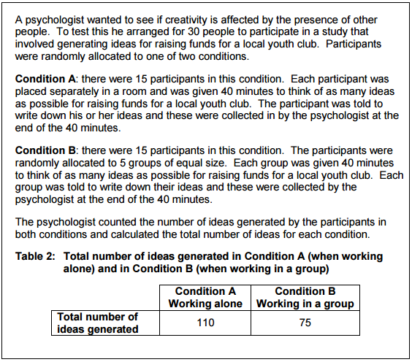

Q1. Write a non-directional hypothesis for this experiment.

Q2. Write a null hypothesis for this experiment.

Q3. What is the design of this experiment? Use a quote from the text to explain how you know

Q4. Identify and explain an advantage of using this design for this experiment.

Q5. Identify and explain a disadvantage of using this design for this experiment.

Q6. Should the null hypothesis be accepted or rejected? Explain your answer.

Q7. Identify one way that the experimenter has improved the internal validity of this experiment.

Q8. Does this study have high or low ecological validity? Explain your answer.

