International Dimensions September 2020
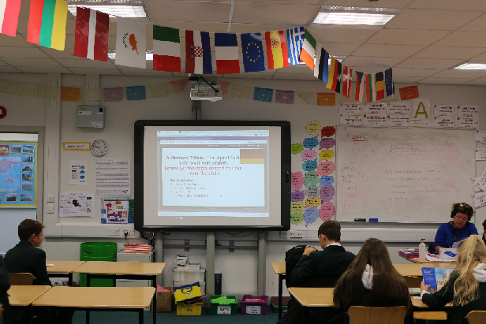
It has been a very active month for international activities. Modern Foreign Languages organised a inter learning mentor group quiz to celebrate International Translation Day. Students across Years 7, 8 and 9 all took part, translating phrases from a range of languages, which even included Icelandic and Japanese! In Year 7 and 8 Carne House were victorious with Masefield House winning in Year 9. Massive thanks to Mrs. Perkins and all Key Stage 3 Learning Mentors for making this such a success. Plans are now a foot to make this an annual competition.
Year 7 students also took part in lessons exploring ‘Peace’ and the meaning of ‘Conflict’. After the sessions, which were delivered by the BUSIT teaching Team, students filled in exit passes to consolidate their understanding. These were sent off to our partner school SAI, in India, for their students to review and feedback. Thanks to Mr. Taylor and his team for making this activity run so smoothly.
English also used the international peace project with SAI to challenge their top sets. Students were asked to reflect on what peace means to them and write a poem. These were then video recorded and sent to SAI, India, for their students to critique and provide feedback. Thanks to Mrs. Wardhaugh and Mrs. Wright for supporting the project and inspiring your students to write such beautiful, heartfelt poems. They were truly amazing!
Looking forward:
10th October 2020: World Mental Health Day World Food Day
16th October 2020: World Food Day
And week commencing 19th October is One World Week the theme this year is ‘It is Our World Let’s Make it Better!’.

