International Dimensions October 2020
It has been another very active month for international activities, with students across all year groups participating in the World Mental Health Day on 10th October, One World Week commencing 12th October 2020 and World Food Day on 16th October 2020.
10th October 2020 World Mental Health Day
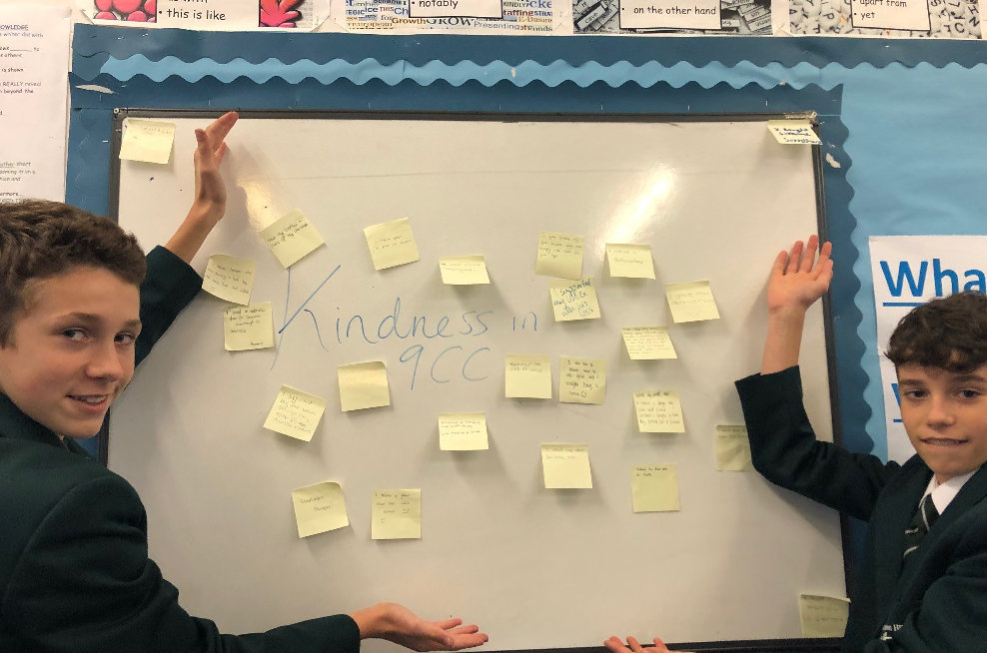
In preparation for the World Mental Health Day, and alongside many thousands of students across the World, every learning mentor group within the school received a presentation on how to recognise mental health issues and where to seek help and advice. Students were then encouraged to take part in the mental health charity Mind’s ‘Do One Thing’ project on Saturday 10th October 2020. This involved Chosen Hill students voluntarily doing one act of random kindness in their own time for another person and then explaining to their classmates what they did on the following Monday. Some did this by writing their acts of kindness on Post-It notes to form a display, whilst others filled in self-reflection slips. Over 600 students chose to do an act of kindness, demonstrating solidarity with their peers across the Globe and just how kind and caring they are.
One World Week ‘It’s Our World Let’s Make It Better’ Quiz
During the week commencing 16th October all our students were given the opportunity to participate in a competition based on their understanding of global climate change. This took the form of a short quiz that each Learning Mentor was asked to do with their mentees. The purpose of the activity was to help raise awareness within our student cohort of the environmental issues affecting the entire World and the role they can play in helping reduce pollution and slow down global warming.
Over 300 students across Years 8, 9, 10, 12 and 13 took part with the results as follows:
Winners: Whittle
Runners Up: Carne
Third: Masefield
Fourth: Scott
These results will contribute to the wider Inter-house competition

World Food Day 16th October 2020
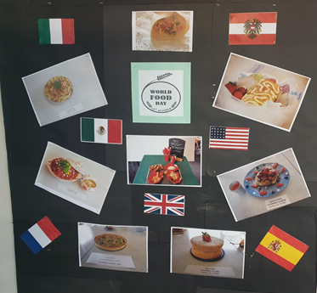
This was far too large a task to do on just one day so Students of DT Food across all year groups have been learning about different cuisines in a range of countries including, France, Germany, Italy, Poland, Spain, UK and USA throughout the last few months. Having successfully cooked some of the recipes from these countries students chose to mark the day by making a wall display of the different international recipes that they had successfully produced.
Looking forward:
20th November 2020 - Africa Industrialization Day - Students studying Globalisation in their Business Studies and Economics lessons will do activities based around the economic development of African nations.
25 November 2020 - International Day for the Elimination of Violence against Women – The Ethical and Personal Studies Team are planning a series of lessons on Forced Marriage to Year 9 and Sociology are teaching about domestic violence in the coming weeks. Students will also be asked to bring in donations for Refuge or similar charities.

