International Dimensions November 2020
During November students at Chosen Hill School participated in two international activities:
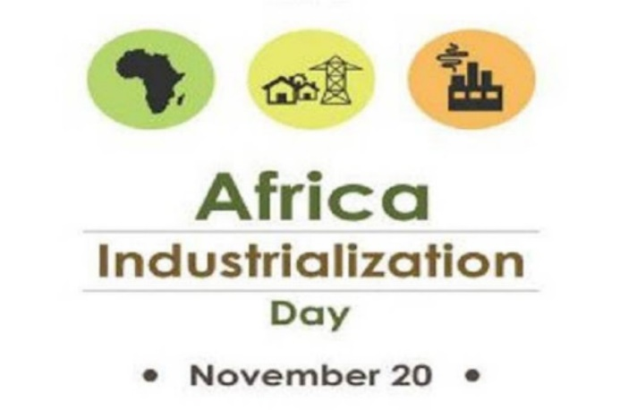
African Industrialisation Day
On 20th November 2202, all students studying Business Studies were invited to watch a series of videos explaining how the African continent is rapidly developing. They learnt about which African countries are developing the fastest, what industries they are developing world-class expertise in and the impact this is having on education, skills, training and standard of living in those countries.
They were then asked to demonstrate what they had discovered by taking part in a virtual quiz.
We are delighted to report that 127 students, across 14 different Business Studies teaching sets, ranging from Year 9 to Year 13, voluntarily took part. The year group that had the most participants and scored highest was Year 9 and the house that won the competition overall was Masefield, with Whittle second, Scott third and Carne fourth.
International Day for the Elimination of Violence against Women
On the 25th November each year the UN promotes the work being carried out around the World aimed at creating greater global awareness of the ongoing problem of violence against women and the actions being taken towards its elimination. Violence against women and girls is one of the most widespread, persistent and devastating human rights violations in our world today remaining largely unreported due to the impunity, silence, stigma and shame surrounding it.
Chosen Hill School remains committed to ensuring that all our students are well-informed about this issue, understand it to be wrong and realise the role they can play in helping eradicate it. This year, during the weeks leading up to the 25th November 2020, both male and female Year 7 students learned about Female Genital Mutilation (FGM) in their EPS lessons. Meanwhile, Year 12 Sociology students learned about domestic violence – what it is, what causes it and the steps to take if they find themselves in an abusive relationship. However, our support for this global initiative doesn’t end there, in fact it continues throughout the academic year with the delivery of a range of lessons covering pertinent issues such as healthy relationships, forced marriage, child marriage and human trafficking, to mention just a few.
Looking forward to the start of 2021:
4 January - World Braille Day. The Inclusion Team have agreed to plan a whole school Learning Mentor Group activity aimed at raising awareness of the importance of braille as a means of communication in the full realization of the human rights for blind and partially sighted people.
11 February - International Day of Women and Girls in Science. The Science Faculty are currently formalising their plans and are considering the following options to conduct with Year 9 Science classes on the day:
· Poster Competition of famous Female Scientist/Engineer
· Live webchats with female scientists’ form STEM ambassador network
· Recreation of experiments done by famous female scientists

Partnership School Activity – Having successfully completed the combined Peace Project earlier this year, we are currently in discussions with our partner school in India (SAI International) about possible new shared projects that will start next year.

Further, MFL are currently exploring ways to further develop relationships and learning activities with partner schools in France and Germany.

We are also hopeful that the British Council will grant Thanthwe Primary School, Malawi, partner school status so we can continue our valuable work helping them complete the build of two new classrooms, which we started back in 2017, and move on to projects aimed at developing combined cultural exchange and learning activities.

More information on all these ongoing initiatives will follow in the New Year.

