International Dimensions February 2021
Three exciting international activities took place throughout February:
11th February 2021 International Day of Women and Girls in Science
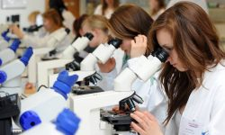
Dr. Ruth Dennis organised a video conference with Dr. Emma Yhnell, who is a research scientist at the University of Cardiff and an ex-chosen hill student, to talk to Year 9 about her favourite female scientist and who inspired her to become a scientist. The on-line discussion was also used to launch a poster competition for students to research their favourite female scientists, with Amazon vouchers being presented for the best entries. The aim being to create awareness of the excellent work being carried out by female scientists across the Globe and to encourage some of our Year 9 girls to seriously consider a future career in a science field.
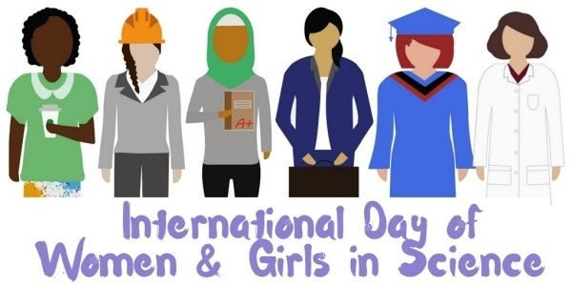
A recoding of the session and the poster competition were forwarded to our partner school SAI, India, too. Female students at that school will send their posters to Chosen Hill School for judging and visa-versa, giving an additional international dimension to this mini project activity.
A massive thank you to Dr. Ruth Dennis for all her hard work organising this important event and subsequent competition.
World Challenge – Namibia 2022
Miss Stephanie Clark (Head of Social Sciences) and Miss Katie Lockett (Head of Modern Foreign Languages) launched the World Challenge Expedition to Namibia, Summer 2022. This is an amazing opportunity for students at Chosen Hill School to visit a sub-Saharan country, experience the culture, traditions and wildlife, whilst participating in a community project and a safari. Students in Year 10 and above have been invited to apply. To find out more follow this link: https://www.youtube.com/watch?v=FA_cBMq0c2Q&feature=youtu.be
To apply click here: https://ourworldchallenge.com/emsz6xh
22nd Feb – 7th March 2021 Fairtrade Fortnight
During this two-week period every learning mentor group was given the opportunity to watch a virtual assembly presentation about what ‘Fairtrade’ means, the role of the Fairtrade Organisation and how our purchase decisions can have a massive impact on the livelihoods of some of the World’s poorest people. This was followed up by a factsheet containing key information about how we can all help slow down climate change, and improve the lives of everyone on Earth, by simply making ‘Fairtrade’ choices. Then, each learning mentor group took part in a quiz to assess how well this issues were understood with points going towards the inter-house competition. At the time of writing, results were still coming in so we hope to announce the winning house in next month’s newsletter. Alongside these activities, learning mentors also encouraged our students to submit entries into the Fairtrade Organisation’s Youth Exhibition 2021, join some of their campaigns and to look out for the Fairtrade logo when shopping.

