Drama Bridging Task Booklet
Task 1 – Option 1 (Do this or Option 2)
Character Design – Costume / Make-Up / Hair
Below you will find an image of actors in role, write 500 words about the choices made by the designers, describe and analyse the choices made. What do you think the theatre makers wanted to communicate to the audience?
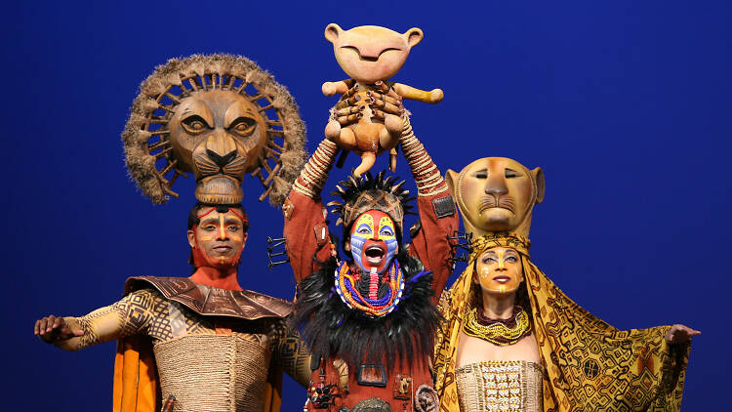
Use the learning mats on the following pages to support your answer.
Ensure that you refer to key elements on these learning mats.
As an example:
“The actor playing Mufasa on the left of the picture has his face painted with bright colour along the line of the nose from the brow to the tip. As part of the costume a large headdress is used to represent the size of the animal he is playing and to represent the status”
Stage Production – The Lion King
Task 1
Option 2 - Stage Design – Set / Lighting / Sound (Do this or Option 1)
Below you will find an image of a set, write 500 words about the choices made by the director and designers, describe and analyse the choices made. What do you think the theatre makers wanted to communicate to the audience?
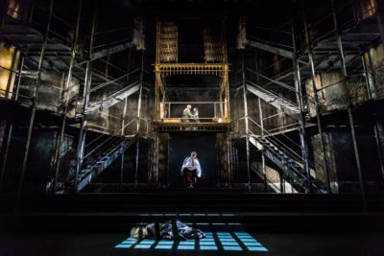
Use the learning mats on the following pages to support your answer.
Ensure that you refer to key elements on these learning mats.
As an example:
The colour palette of the set is very muted and not very bright, this may have been used to suggest that the play is very bleak. It is dimly lit and the staircases are quite plain. When the light, which is quite dim, is shone through the stairways it creates patterns that are somewhat skeletal.
Stage Production – Sweeney Todd

