A Level Chemistry
Induction Task

Name: ___________________
Mark: _____/100
There are two tasks in the induction:
Part A is a series of past paper questions, which will be marked, assessed and feedback given on.
Part B is a written task asking you to outline your motivations for studying A Level Chemistry. This will not be assessed – think of it as a way to get to know you!

Part A
Q1.
When sodium thiosulfate solution reacts with dilute hydrochloric acid, the solution becomes cloudy.
The equation for the reaction is:
Na₂S₂O₃(aq) + 2 HCl(aq) ⟶ 2 NaCl(aq) + SO₂(g) + H₂O(l) + S(s)
(a) Why does the solution become cloudy?
___________________________________________________________________
___________________________________________________________________
___________________________________________________________________
___________________________________________________________________
(2)
Some students used this reaction to investigate the effect of concentration on rate of reaction.
The diagram shows the apparatus used.
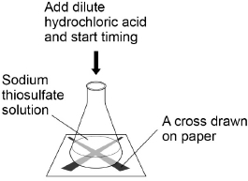
This is the method used.
1. Measure 25 cm³ sodium thiosulfate solution into a conical flask.
2. Stand the conical flask on a cross drawn on paper.
3. Add 10 cm³ of dilute hydrochloric acid.
4. Time how long it takes the cross to become no longer visible.
5. Repeat steps 1–4 with sodium thiosulfate solutions of different concentrations.

(b) The students used a measuring cylinder to measure 25 cm³ of sodium thiosulfate solution.
Suggest a more accurate way of measuring 25 cm³ of sodium thiosulfate solution.
___________________________________________________________________
___________________________________________________________________
(1)

(c) Name one control variable the students should use in this investigation.
___________________________________________________________________
(1)

The table shows the students’ results.

Concentration of sodium thiosulfate solution in mol / dm³ | Time for cross to become no longer visible in s
0.020 | 170
0.040 | 90
0.060 | 82
0.080 | 42
0.100 | 34
0.120 | 30
0.140 | 28

(d) Plot the data from the table on the previous page on the graph below.
Draw a line of best fit.
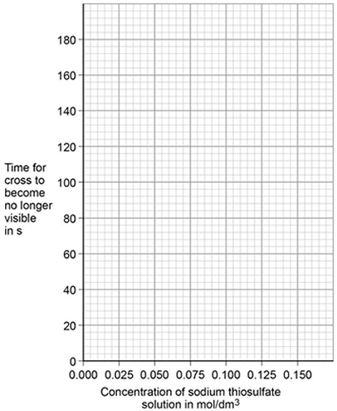
(3)
The students repeated the investigation two more times.
(e) Describe how the students can use their results to improve the accuracy of the investigation.
___________________________________________________________________
___________________________________________________________________
___________________________________________________________________
___________________________________________________________________
(2)

(f) The students analysed their results to give a conclusion and an explanation for their investigation.
Conclusion: ‘The higher the concentration, the lower the rate of reaction.’
Explanation: ‘At higher concentrations, the particles have more energy, so they are moving faster. Therefore the collisions are more energetic.’
The students are not correct.
Give a correct conclusion and explanation for the results of the investigation.
Conclusion _________________________________________________________
___________________________________________________________________
___________________________________________________________________
Explanation _________________________________________________________
___________________________________________________________________
___________________________________________________________________
___________________________________________________________________
___________________________________________________________________
(3)
(h) A solution containing 0.18 g of sodium thiosulfate reacts with dilute hydrochloric acid in 2 minutes.
Calculate the mean rate of reaction in g / s.
Give your answer in standard form.
___________________________________________________________________
___________________________________________________________________
___________________________________________________________________
___________________________________________________________________
Mean rate of reaction = ____________________ g / s
(3)
(Total 15 marks)

Q2. Read the article and then answer the questions.

Supermarkets launch eco-friendly plastic milk bags.
Could this be the end of the milk bottle?
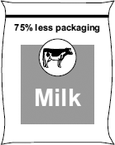
Milk bottles are made from glass or from plastic.
Glass milk bottles contain 0.5 litres of milk. When the milk is used up the empty
bottles are returned to be re-used. Glass milk bottles are re-used 24 times on
average. The glass to make new milk bottles is produced when a mixture of sand,
limestone, soda and recycled glass is heated to about 1600 °C in a furnace. There
are almost unlimited amounts of the raw materials needed to produce this glass.
About 35% of used glass is recycled.
The most common plastic milk bottles contain 2 litres of milk. When the milk is
used up the empty bottles are discarded as waste. The plastic used to make these
milk bottles is poly(ethene). Poly(ethene) is produced from crude oil by first using
fractional distillation, then cracking the naphtha fraction and finally polymerising the
ethene. About 5% of used poly(ethene) is recycled.
The new plastic milk bags contain 2 litres of milk. The milk bags are also made
from poly(ethene). A milk bag uses 75% less poly(ethene) than is used to make the
poly(ethene) milk bottles. When the milk is used up the empty bags are discarded as
waste.
(b) Supermarkets claim that using milk bags instead of milk bottles would have less environmental impact.
Do you agree with this claim?
Use the information in the article and your knowledge and understanding to make appropriate comparisons to justify your answer.
___________________________________________________________________
___________________________________________________________________
___________________________________________________________________
___________________________________________________________________
___________________________________________________________________
CONTINUE YOUR ANSWER ON THE NEXT PAGE
___________________________________________________________________
___________________________________________________________________
___________________________________________________________________
___________________________________________________________________
___________________________________________________________________
___________________________________________________________________
___________________________________________________________________
___________________________________________________________________
___________________________________________________________________
___________________________________________________________________
(4)

(a) Describe what happens in fractional distillation so that fractions, such as naphtha, are separated from crude oil.
___________________________________________________________________
___________________________________________________________________
___________________________________________________________________
___________________________________________________________________
___________________________________________________________________
___________________________________________________________________
(3)

(Total 7 marks)

Q3.
Nitrogen and hydrogen react to produce ammonia in the Haber process.
Figure 1 shows the Haber process.
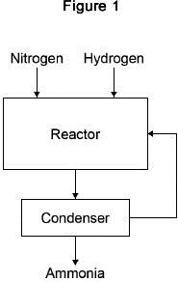
A gaseous mixture of ammonia, hydrogen and nitrogen leaves the reactor.
Table 1 shows the boiling points of the gases.

Table 1
Gas | Boiling point in °C
Ammonia | −33
Nitrogen | −196
Hydrogen | −253
(a) Suggest how ammonia is separated from the other gases.
___________________________________________________________________
___________________________________________________________________
___________________________________________________________________
___________________________________________________________________
___________________________________________________________________
(2)
(b) What happens to the unreacted hydrogen and nitrogen?
___________________________________________________________________
___________________________________________________________________
(1)
The equation for the reaction is:
N₂(g) + 3H₂(g) ⇌ 2NH₃(g)
The forward reaction is exothermic.
(c) Calculate the volume of ammonia produced from the complete reaction of 825 dm ³ of hydrogen.
___________________________________________________________________
___________________________________________________________________
___________________________________________________________________
___________________________________________________________________
Volume of ammonia = ____________________ dm ³
(2)
(d) The Haber process uses a temperature of 450 °C and a pressure of 200 atmospheres.
Why are these conditions used?
Tick two boxes.

A higher pressure is maintained using less energy
A higher temperature would increase the equilibrium yield
A lower pressure would decrease the equilibrium yield
A lower temperature would make the reaction too slow
There are more product molecules than reactant molecules
(2)

Most of the ammonia produced is used to make fertilisers.
Table 2 shows information about compounds used as fertilisers.

Table 2
Compound | Formula | Cost in £ / tonne
A | NH₄NO₃ | 220
B | (NH₄)₂HPO₄ | 350
C | KCl | 235
(e) Which element in compound A improves agricultural productivity?
___________________________________________________________________
(1)
(f) Which two compounds can be mixed to make a fertiliser containing three elements that improve agricultural productivity?
Give a reason why you have chosen these compounds.
Compounds ___________ and ___________
Reason ____________________________________________________________
___________________________________________________________________
(2)
(g) Figure 2 shows a flow chart for the production of compounds B and C.
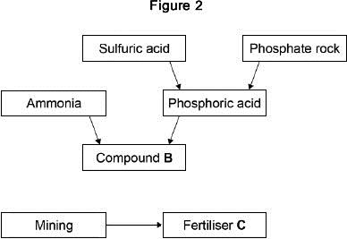

Suggest two possible reasons for the difference in cost between compounds B and C in figure 2.
1. _________________________________________________________________
___________________________________________________________________
2. _________________________________________________________________
___________________________________________________________________
(2)
(Total 12 marks)
Q4.
A student investigated food dyes using paper chromatography.
This is the method used.
1. Put a spot of food colouring X on the start line.
2. Put spots of four separate dyes, A, B, C and D, on the start line.
3. Place the bottom of the paper in water and leave it for several minutes.
Figure 1 shows the apparatus the student used.
Figure 1
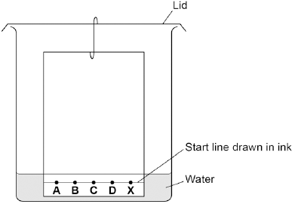
(a) Write down two mistakes the student made in setting up the experiment and explain what problems one of the mistakes would cause.
___________________________________________________________________
___________________________________________________________________
___________________________________________________________________
___________________________________________________________________
(2)

(b) Another student set up the apparatus correctly.
Figure 2 shows the student’s results. The result for dye D is not shown.
Figure 2
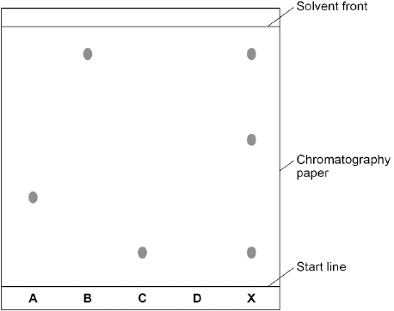
Calculate the R_{f} value of dye A
Give your answer to two significant figures.
___________________________________________________________________
___________________________________________________________________
___________________________________________________________________
___________________________________________________________________
R_{f} value = ______________________
(3)
(c) Dye D has an R_{f} value of 0.80. Calculate the distance that dye D moved on the chromatography paper.
___________________________________________________________________
___________________________________________________________________
Distance moved by dye D = ______________________
(1)

(d) Explain how the different dyes in X are separated by paper chromatography.
___________________________________________________________________
___________________________________________________________________
___________________________________________________________________
___________________________________________________________________
___________________________________________________________________
___________________________________________________________________
___________________________________________________________________
___________________________________________________________________
(4)

(Total 10 marks)
Q5. This question is about metal compounds.
(a) Lithium reacts with chlorine to produce lithium chloride.
When lithium atoms and chlorine atoms react to produce lithium chloride, lithium ions and chloride ions are formed.
The diagram shows the electronic structures of the atoms and ions.
The symbols o and x are used to represent electrons.
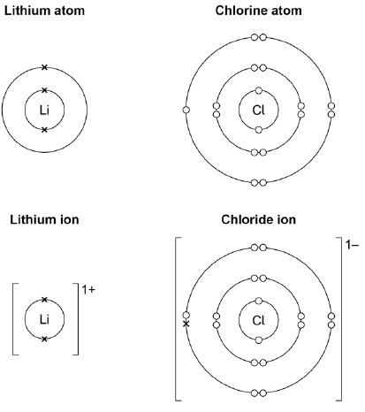
Figure 1

Describe what happens when a lithium atom reacts with a chlorine atom. (Use Figure 1 on the previous page)
Answer in terms of electrons.
___________________________________________________________________
___________________________________________________________________
___________________________________________________________________
___________________________________________________________________
___________________________________________________________________
___________________________________________________________________
___________________________________________________________________
(4)
Zinc sulfate can be made by two methods. The equations for the two methods are:
Method 1: ZnO + H₂SO₄ ⟶ ZnSO₄ + H₂O
Method 2: ZnCO₃ + H₂SO₄ ⟶ ZnSO₄ + H₂O + CO₂
(b) Calculate the percentage atom economy for making zinc sulfate in Method 1.
Use the equation:
percentage atom economy =
Give your answer to 3 significant figures.
Relative formula masses (M_{r}): ZnO = 81 H₂SO₄ = 98 ZnSO₄ = 161
___________________________________________________________________
___________________________________________________________________
___________________________________________________________________
___________________________________________________________________
___________________________________________________________________
Percentage atom economy = ____________________ %
(3)

(c) Method 1 gives a higher percentage atom economy for making zinc sulfate than Method 2.
Give a reason why it is important to use a reaction with a high atom economy.
___________________________________________________________________
___________________________________________________________________
(1)
(d) A student uses 50 cm ³ of a zinc sulfate solution of 80 g/dm ³
What mass of zinc sulfate is dissolved in 50 cm ³ of this zinc sulfate solution?
___________________________________________________________________
___________________________________________________________________
___________________________________________________________________
___________________________________________________________________
Mass = ____________________ g
(2)
(Total 10 marks)
Q6. Soluble salts are formed by reacting metal oxides with acids.
(a) Give one other type of substance that can react with an acid to form a soluble salt.
___________________________________________________________________
(1)
(b) Calcium nitrate contains the ions Ca²⁺ and NO₃⁻
Give the formula of calcium nitrate.
___________________________________________________________________
(1)
(c) Describe a method to make pure, dry crystals of magnesium sulfate from a metal oxide and a dilute acid.
There is additional space on the next page.
___________________________________________________________________
___________________________________________________________________
___________________________________________________________________
___________________________________________________________________
___________________________________________________________________
___________________________________________________________________
___________________________________________________________________
___________________________________________________________________
___________________________________________________________________
___________________________________________________________________
___________________________________________________________________
___________________________________________________________________
___________________________________________________________________
___________________________________________________________________
___________________________________________________________________
___________________________________________________________________
___________________________________________________________________
___________________________________________________________________
___________________________________________________________________
(6)
(Total 8 marks)
Q7. Crude oil is a mixture of mostly alkanes.
(a) Crude oil is separated into useful fractions by fractional distillation.
(i) Describe and explain how the mixture of alkanes is separated by fractional distillation.
______________________________________________________________
______________________________________________________________
______________________________________________________________
______________________________________________________________
______________________________________________________________
______________________________________________________________
______________________________________________________________
(3)

(ii) The table gives the name and formula for each of the first three alkanes.
Complete the table to show the formula of butane.

Name of alkane | Formula
Methane | CH₄
Ethane | C₂H₆
Propane | C₃H₈
Butane
(1)
(b) The structural formula of methane, CH₄, is:
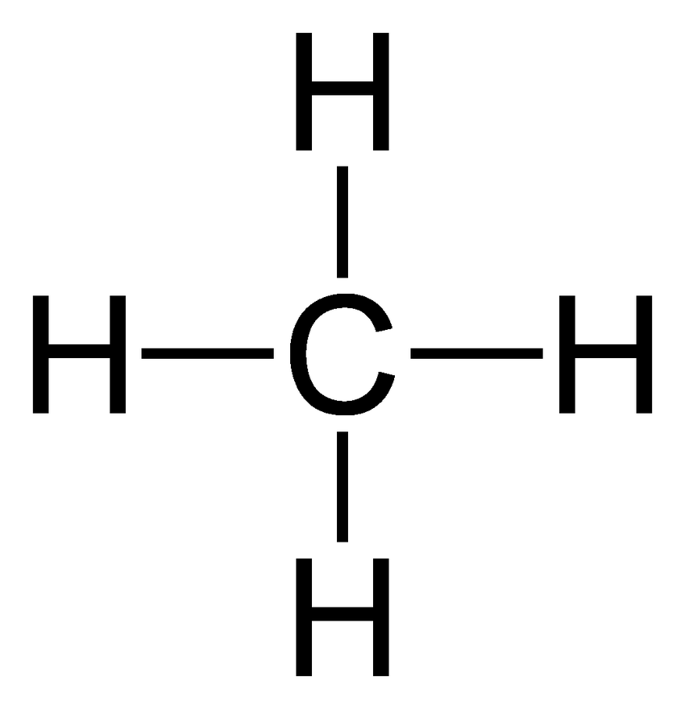
Draw the structural formula of propane, C₃H₈

(1)

(c) The relative amounts of and the market demand for some hydrocarbons from the fractional distillation of crude oil are shown in the graph.
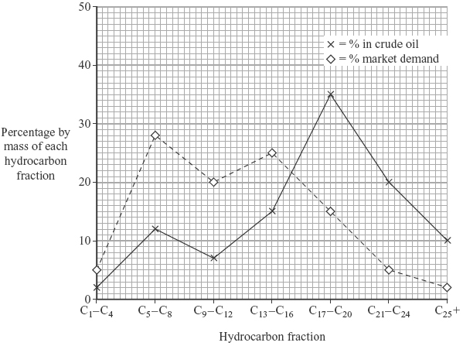
(i) Why is the market demand for the C₅ – C₈ fraction higher than the market demand for the C₂₁ – C₂₄ fraction?
______________________________________________________________
______________________________________________________________
(1)
(ii) Cracking is used to break down large hydrocarbon molecules into smaller hydrocarbon molecules.
Complete the symbol equation by writing in the formula of the other hydrocarbon.
C₂₀H₄₂ C₁₆H₃₄ + 2 _____________________
(1)

(iii) The C₅ – C₈ fraction has low supply and high market demand.
Suggest three ways in which the oil industry could overcome this problem.
1. ____________________________________________________________
______________________________________________________________
2. ____________________________________________________________
______________________________________________________________
3. ____________________________________________________________
______________________________________________________________
(3)
(Total 10 marks)
Q8.
Methanol (CH₃OH) can be made by reacting methane (CH₄) and oxygen (O₂).
The reaction is exothermic.
The equation for the reaction is:
(a) The energy level diagram for this reaction is given below.
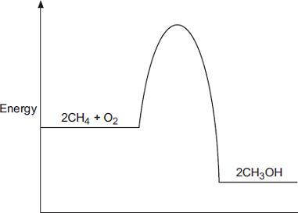
(i) How does the diagram show that this reaction is exothermic?
______________________________________________________________
______________________________________________________________
______________________________________________________________
(1)

(ii) A platinum catalyst can be used to increase the rate of this reaction.
What effect does adding a catalyst have on the energy level diagram?
______________________________________________________________
______________________________________________________________
______________________________________________________________
(1)
(b) The equation can also be written showing the structural formulae of the reactants and the product.
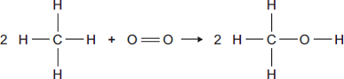
(i) Use the bond energies given in the table to help you to calculate the energy change for this reaction.

Bond | Bond energy in kJ
 | 435
 | 497
 | 336
 | 464
______________________________________________________________
______________________________________________________________
______________________________________________________________
______________________________________________________________
Energy change = ____________________ kJ
(3)
(iii) In terms of the bond energies, why is this an exothermic reaction?
______________________________________________________________
______________________________________________________________
(1)
(Total 6 marks)

Q9.
The diagram below represents different models of the atom.
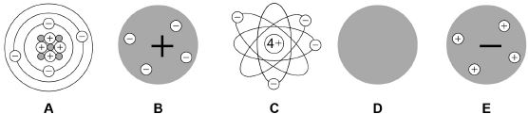
(a) Which diagram shows the plum pudding model of the atom?
Tick one box.
(1)
(b) Which diagram shows the model of the atom developed from the alpha particle scattering experiment?
Tick one box.
(1)
(c) Which diagram shows the model of the atom resulting from Bohr’s work?
Tick one box.
(1)
(d) Define the mass number of an atom.
___________________________________________________________________
___________________________________________________________________
(1)

(e) Element X has two isotopes. Their mass numbers are 69 and 71
The percentage abundance of each isotope is:
• 60% of ⁶⁹X
• 40% of ⁷¹X
Estimate the relative atomic mass of element X.
Tick one box.

< 69.5
Between 69.5 and 70.0
Between 69.5 and 70.0
Between 70.0 and 70.5
> 70.5
(1)
(f) Chadwick’s experimental work on the atom led to a better understanding of isotopes.
Explain how his work led to this understanding.
___________________________________________________________________
___________________________________________________________________
___________________________________________________________________
___________________________________________________________________
___________________________________________________________________
___________________________________________________________________
(3)
(Total 8 marks)

Q10.

This question is about acids and alkalis.

(a) Dilute hydrochloric acid is a strong acid.

Explain why an acid can be described as both strong and dilute.

___________________________________________________________________

___________________________________________________________________

___________________________________________________________________

___________________________________________________________________

(2)

(b) A 1.0 × 10⁻³ mol/dm³ solution of hydrochloric acid has a pH of 3.0

What is the pH of a 1.0 × 10⁻⁵ mol/dm³ solution of hydrochloric acid?

pH = ___________________

(1)

A student titrated 25.0 cm³ portions of dilute sulfuric acid with a 0.105 mol/dm³ sodium hydroxide solution.

(c) The table below shows the student’s results.

 | Titration  1 | Titration  2 | Titration  3 | Titration  4 | Titration  5
Volume of sodium hydroxide solution in cm³ | 23.50 | 21.10 | 22.10 | 22.15 | 22.15

The equation for the reaction is:

2 NaOH + H₂SO₄ ⟶ Na₂SO₄ + 2 H₂O

Calculate the concentration of the sulfuric acid in mol/dm³

Use only the student’s concordant results.

Concordant results are those within 0.10 cm³ of each other.

There is additional space on the next page.

___________________________________________________________________

___________________________________________________________________

___________________________________________________________________

___________________________________________________________________

___________________________________________________________________

___________________________________________________________________

___________________________________________________________________

___________________________________________________________________

___________________________________________________________________

___________________________________________________________________

Concentration of sulfuric acid = ___________________ mol/dm³

(5)

(d) Explain why the student should use a pipette to measure the dilute sulfuric acid and a burette to measure the sodium hydroxide solution.

___________________________________________________________________

___________________________________________________________________

___________________________________________________________________

___________________________________________________________________

(2)

(e) Calculate the mass of sodium hydroxide in 30.0 cm³ of a 0.105 mol/dm³ solution.

Relative formula mass (M_{r}): NaOH = 40

___________________________________________________________________

___________________________________________________________________

___________________________________________________________________

___________________________________________________________________

Mass of sodium hydroxide = ___________________ g

(2)

(Total 12 marks)

END OF QUESTIONS

Part B

Write a summary outlining why you want to study A Level Chemistry.

Include any topic areas that you have found interesting in your studies so far, as well as any ideas you have about university/careers.

__________________________________________________________________________________________________________________________________________________________________
___________________________________________________________________________________________________________________________________________________________________________________________________________________________________________________
___________________________________________________________________________________________________________________________________________________________________________________________________________________________________________________
___________________________________________________________________________________________________________________________________________________________________________________________________________________________________________________
___________________________________________________________________________________________________________________________________________________________________________________________________________________________________________________
___________________________________________________________________________________________________________________________________________________________________________________________________________________________________________________

