Applied Science Summer work - The work of scientists
Much of the work on this course is applied to the work of scientists. To start the course well you will need an understand of the work of different scientists. Please complete the table below to give you an overview of what they study and how their work is used in our world.
A good starting point is https://www.prospects.ac.uk/job-profiles/browse-a-to-z but you must summarise each section in your own words.
Email your work to SE@chosen-hill.gloucs.sch.uk by 31st August
Type of scientist | What they study | A real life example of what they might work on.
Biologist
- Marine biologist
- Zoologist
Biomedical scientist
Chemist, including biochemistry and analysts
Environmental scientist (ecologist)
Geneticist
Material scientist
Microbiologist
Pharmacologist
Physicist
Product/process developer or technologist, eg polymers or food (biotechnologist)
Radiographer/radiologist
Research scientist
Scientific laboratory technician
Sport and exercise scientist
Toxicologist

Applied Science Unit 2 coursework summer work
In Applied Science 50% of the course is coursework. One of the most useful skills you can practice during the holidays is the ability to follow an assignment brief. We have included snippets from each of the 3 sciences assignments you will face next year. You should use the grids to mark them and make then add to them to make improvements. Look at the performance outcome in each case. Decide whether you would award Working Towards (WT), Pass (P1), Merit (M1) or distinction (D1) in each case. Then look at what the student has missed out and use your GCSE knowledge to improve their work.
Performance outcomes | Working Towards | PASS | MERIT | DISTINCTION | Notes
PO1  Demonstrate experimental techniques in Biology | WT  Some content but not sufficient to reach the passing standard | P1  Outline the use of peak flow in relation to rate of respiration. | M1  Explain the scientific principles of how we breathe and how the peak flow machine works. | D1  Explain how peak flow can be applied in a medical or commercial context, what are the normally expected values, what does it mean if the peak flow does not produce a normal value. What conditions could abnormal values indicate in a patient?
Example of student biology work (Read this through to decide their grade)
Peak flow meter:
Peak flow metres are used to test for asthma. The machine measures how much air a person is able to blow out of their lungs over a set period. Keeping track of the results of a peak flow meter reading can help to check if asthma symptoms are getting better or worse. Peak flow meters are used to help stop an asthma patient from seeking emergency medical attention as they can alert the narrowing or tightening of the airways days before an asthma attack occurs. The device can also help people find out the cause of the asthma and if their medication should be changed. Peak flow values are most useful when they are checked at the same time each day. For example, once in the morning and once at night.

Using a peak flow meter.
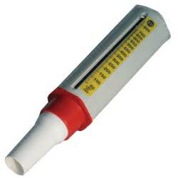
A peak flow meter is used to measure peak expiratory flow rate. There are many different types of peak flow meter, some measure the forced expiratory volume per second. They are used to test people for asthma. This is done by an exercise activity as it is a common trigger for asthma. The test measures how fast you can breathe out; this is to see how well your lungs work. The Peak Flow meter works like this:
- Take a sterile mouthpiece and attach it correctly to the peak flow meter using instructions from the packet. The mouthpiece must not be wet.
- Make sure you’re sat up right or stood up and hold the peak flow meter level so it is not slanting. Make sure your hands are not covering any air exit holes. Also ensure that the marker is at the lower end of the scale.
- Take in a deep breath, as big as possible, then close your lips firmly around the mouthpiece. Ensure that the whole of the mouthpiece is covered so no air can escape out the sides.
- Blow into the mouthpiece as hard and as fast as possible. Think of it more as a ‘huff’.
- Note down the value that the flow meter tells you and then push the marker back to the bottom of the scale.
- Repeat the procedure numerous times, note down the highest reading among all of the repeats.
- Exercise mildly for a short period of time. Take readings at 1 minute intervals after the exercise has been completed, compare the readings from before and the readings after doing the exercise.
- Asthma induced airway resistance is noticeable a few minutes after the exercise has stopped.
Breathing:
Breathing works by two main muscles, the intercostal muscles and the diaphragm muscle. When air enters the lungs the muscles are forced open.
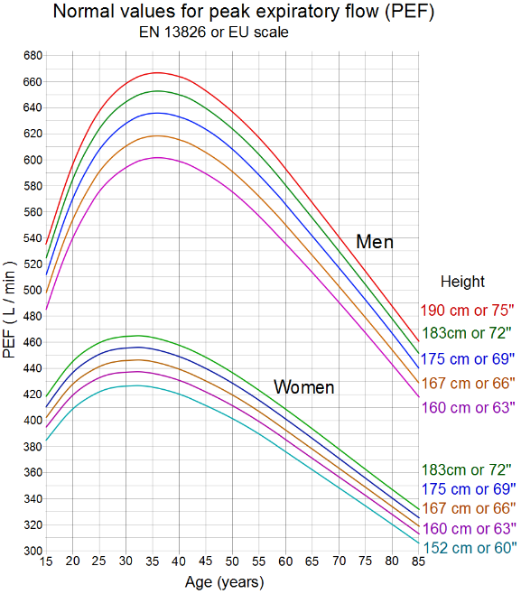
Flow rate:The rate at which air can be expelled during a forced expiration is an effective way of checking for any restriction or resistance that may be causing airways to narrow. A peak flow meter is measured in dm³ per minute. The average results are roughly that men whose height is 167 cm should be on 500dm³ at 15 years old. Many factors affect what results a person will receive on a peak flow meter. These include: Whether they’re male or female, their height and their age. Also if they have a breathing problem such as asthma.

Marking – Y11 students to complete this section
Performance outcomes | Working Towards | PASS | MERIT | DISTINCTION | Notes
PO1  Demonstrate experimental techniques in Biology | WT  Some content but not sufficient to reach the passing standard | P1  Outline the use of peak flow in relation to rate of respiration. | M1  Explain the scientific principles of how we breathe and how the peak flow machine works. | D1  Explain how peak flow can be applied in a medical or commercial context, what are the normally expected values, what does it mean if the peak flow does not produce a normal value. What conditions could abnormal values indicate in a patient?

What grade would you give them (look at the markscheme above)?

Is it well laid out, in a logical order and clear to read?

What could they do to improve?

U2 Specific Heat Capacity Assignment – AQA Marking Grid
Performance outcomes | Pass  To achieve a pass the learner must evidence that they can: | Merit  In addition to the pass criteria, to achieve a merit the learner must evidence that they can: | Distinction  In addition to fulfilling the pass and merit criteria, to achieve a distinction the learner must evidence that they can:
PO3  Demonstrate experimental techniques in Physics | P7  Explain the term  - specific heat capacity (SHC) in relation to material properties. | M7  Describe how the value of SHC determines the uses of materials in industry.
 | Meaning of SHC  Why different materials have different SHCs  Importance of knowing SHC values for materials | Behaviour and uses of a range of materials with high and low values of SHC …including water
Example of student physics work (Read this through to decide their grade)

Specific heat capacity - Introduction
This investigation is taking place in order to find which materials best for the desired specific heat capacity in a car engine. In particular, I will be looking at aluminium.
Vocational link
In a real life situation, an engineer would need to discover what material would be best for keeping the engine as cool as possible. We need to ensure the engine is cool enough so that it does not overheat and burst into flames or not functioning properly, causing a multitude of problems. This means that the specific heat capacity will vary between materials so we will have to test multiple in order to find the best one.
The science behind it
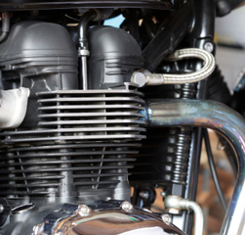
If a material has a high specific heat capacity, it will be able to absorb more of the heat energy from the engine and therefore will reduce the overall temperature. With a coolant being passed over the engine, you will need to ensure that the coolant is able to get to the engine surface to allow the maximum amount of heat to be taken away from the engine. This means you need to have a large surface area, allowing more heat to be accessible. You can increase the surface area in the way you shape the engine, for example, shaping it to look like radiator fins. In this photo, we can see the shape allows more air in this instance to reach the surfaces of the engine, allowing more heat to be taken away from the engine and therefore cooling it down.
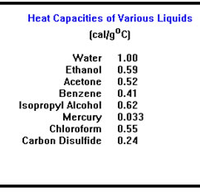
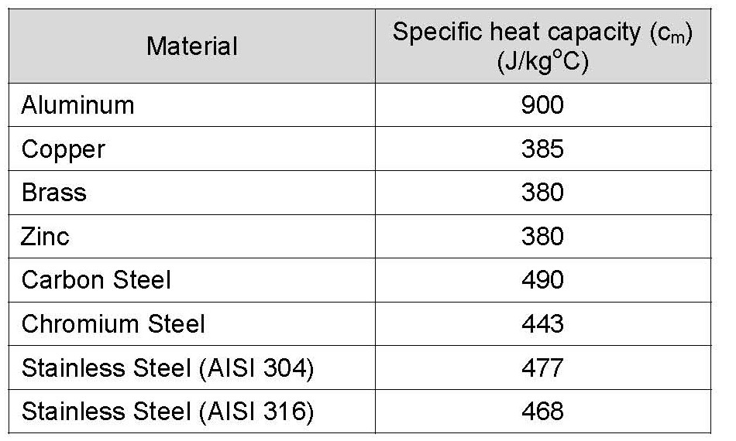
Different material’s specific heat capacity
Here are some examples of a few material’s specific heat capacity, firstly solids, and then a list of liquids that could be used to cool the engine.

U2 Specific Heat Capacity Assignment – AQA Marking Grid
Performance outcomes | Pass  To achieve a pass the learner must evidence that they can: | Merit  In addition to the pass criteria, to achieve a merit the learner must evidence that they can: | Distinction  In addition to fulfilling the pass and merit criteria, to achieve a distinction the learner must evidence that they can:
PO3  Demonstrate experimental techniques in Physics | P7  Explain the term  - specific heat capacity (SHC) in relation to material properties. | M7  Describe how the value of SHC determines the uses of materials in industry.
 | Meaning of SHC  Why different materials have different SHCs  Importance of knowing SHC values for materials | Behaviour and uses of a range of materials with high and low values of SHC …including water

Marking – use the mark scheme to answer this

What grade would you give them?

What could they do to improve?
Year 12 Chemistry Graph skills -

In the coursework you will need to draw graphs and read data this task will help you practice these skills. Read the information and complete the questions

A titration can be used to calculate the concentration of an acid or alkali by gradually adding an alkali or acid of known concentration to it and finding the exact volume needed to neutralise the unknown.

These results show the change in pH of an acid as a base (alkali) is added.

Volume Of Base (mL) | pH
1.00 | 3.15
2.00 | 3.24
3.00 | 3.39
4.00 | 3.54
5.00 | 3.63
6.00 | 3.78
7.00 | 3.85
8.00 | 3.98
9.00 | 4.11
10.00 | 4.20
11.00 | 4.31
12.00 | 4.47
13.00 | 4.60
14.00 | 4.75
15.00 | 4.90
16.00 | 5.20
17.00 | 5.60
18.00 | 6.60
19.00 | 9.92
20.00 | 10.60
21.00 | 11.80
22.00 | 12.25
23.00 | 12.32
24.00 | 12.45

Here are two graphs of these results.
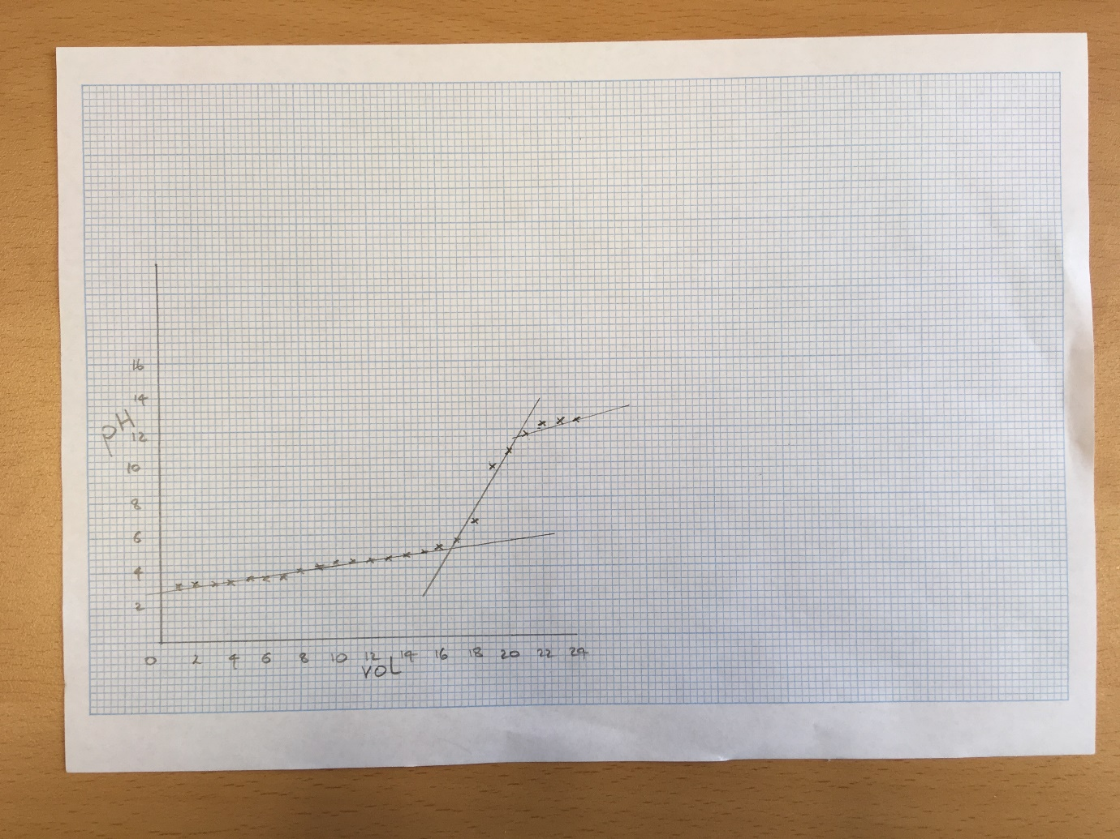
Graph 1
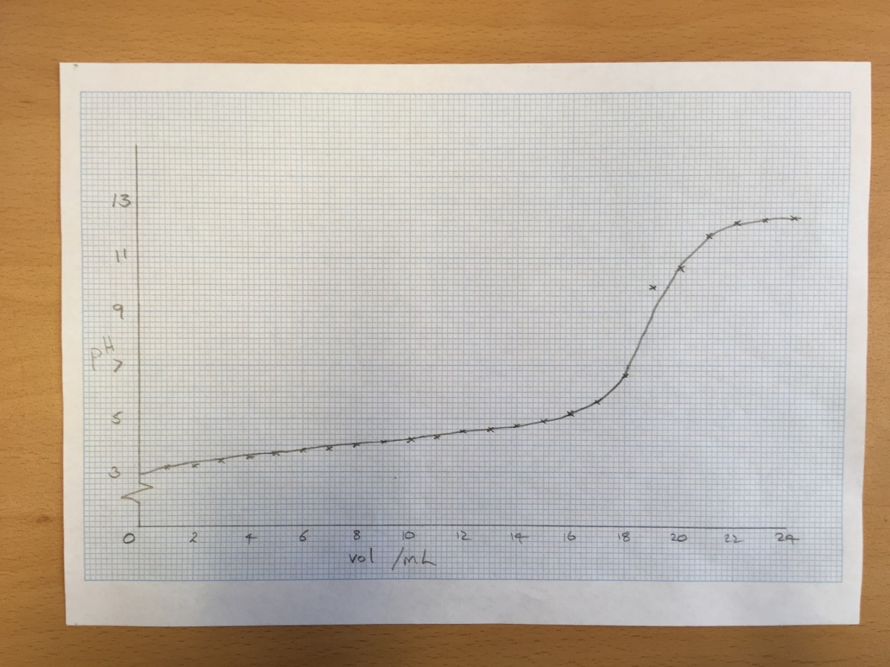
Graph 2
Look at the two graphs and follow and answer the following questions.
- List the mistakes in graph 1. Explain what the student should change.

- List the mistakes in graph 2. Explain what the student should change.

- Plot your own graph of the results clearly on graph paper. (You can find printable graph paper here. https://www.printablepaper.net/preview/Quarter_Inch_Light_Gray_Graph_Paper_Letter)

- Mark clearly on your graph any anomalies.

- Use your graph to find the volume of base needed to neutralise the acid (pH7.00).
- Use your graph to find the pH of the solution when 19.00ml of base have been added.

