

|  |  |
| --- | --- |
| **WELLNESS:** | ensuring that our work supports the emotional, social, and physical |
|  | health of our staff and students |
| **AMBITION:** | a focus on high expectations and aspirations for our students to achieve |
|  | amazing outcomes |
| **TOGETHERNESS:** | high performance comes from an environment of trust and support. We |
|  | need to build and maintain strong community links beyond the school |
| **CONFIDENCE:** | positive feedback, celebration, and a coherent knowledge-rich curriculum |
|  | that gives students self-belief and esteem |
| **HONESTY:** | a willingness to give and receive developmental support alongside strong |
|  | culture of rigorous and frequent evaluation in order to be better every day |

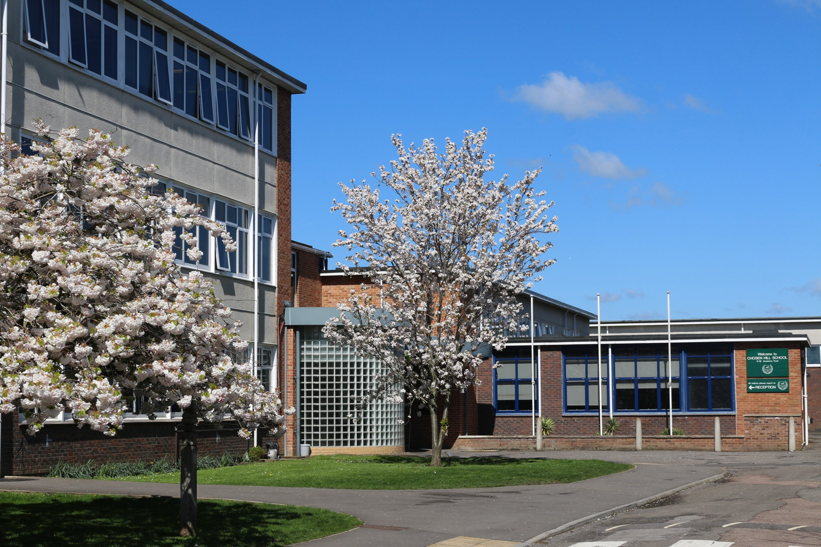



**Contents**

**Headteacher Message** **1**

**Leadership Arrangements and Sixth Form** **2**

## **Co-opted Governor Vacancy 3 - 4**

### The Role of a School Trustee

* Commitment and Meetings
* How to Apply

# Welcome to Chosen Hill School

Thank you for your interest in this very important position at Chosen Hill School.

Chosen Hill School is a happy school where students, staff and parents work closely in partnership. Self-belief, aspiration, and mutual respect are key drivers in the pursuit of a culture of excellence. Our aim is that every individual will experience success. That doesn’t come magically – it is the result of hard work, perseverance and commitment by the student, good teaching, encouragement and feedback from staff.

Key to a student’s success is their attitude to learning and, here at Chosen Hill, we place emphasis on students developing a growth mindset, where students are encouraged to take ownership and responsibility for their learning, whilst being fully supported to do so by a broad, balanced and stimulating curriculum, a rich extracurricular and cultural offer and professional student support services.

You will find a picture of life in a dynamic community where students grow in confidence, independence, leadership, and resilience, not only in their lessons, but in the breadth of Chosen Hill School’s provision. We are very proud of our tradition of student leadership and ensure that students have many opportunities to contribute to the development and success of the school and to act as role models for younger students – from Year 9 Junior Prefects to Year 11 Prefects, from membership of the Year and Whole School Councils to the Sixth Form Leadership Team and House Captains – our young people take responsibility at every stage in their school careers.

We have the highest expectations of our young people, not simply in their progress in learning, but in how they grow as good citizens. We want our students to be people we would be proud to know as our family, friends, and neighbours. When our young people go out into the world, we want them to make a very positive difference. The ethos of the school is that we all help and look out for one another. We have an impressive record of community and charity work both here and abroad, from the hosting of our own Race for Life events to World Challenge students supporting the building of new school buildings in Malawi. We encourage our students to develop as caring and responsible citizens.

Our school is at a very exciting point in its improvement journey. The vision for the school over the next five years is best summed up by our WATCH (Wellness, Ambition, Togetherness, Confidence and Honesty) words which underpin all decisions made by the school. I believe that a strong creative and practical offer for our students is essential to providing a broad and engaging curriculum and I look forward to welcoming successful shortlisted candidates to hear more about how they could help us to develop this further at Chosen Hill School.

**Matthew Pauling**

**Headteacher**

# Chosen Hill School Leadership Arrangements

The Senior Leadership Team includes the Headteacher, two Deputy Headteachers, four Assistant Headteachers and the Business Manager.

The structure comprises of Heads of Faculties for: English, Maths, Science, BUSIT (Business and ICT), DART, Physical Education, Modern Foreign Languages, Performing Arts and Humanities.

A faculty further comprises of Assistant Faculty Leads and Subject Leads.

In conjunction with faculties there are whole school coordinator roles with specific cross school briefs.

# Chosen Hill Sixth Form

Our Sixth Form community is a successful, thriving, and forward-thinking group of individuals who are dedicated to reaching their full potential and preparing for the world beyond school. Our vision to equip students with the skills and knowledge they need to succeed in future life underpins everything that we do. We inspire confidence and ambition in our students through a challenging curriculum and a supportive environment. Our Sixth Form students feel very much part of our whole school community, and this is demonstrated through their actions and successes.

Our students display a love for learning both within the classroom and the wider school community. We have an excellent Student Leadership Programme which allows students to build teamwork, communication, and problem-solving skills. Our Sixth Form students inspire, lead, and support our younger school community through academic support in lessons, House Leadership, Sports, and transition activities.

We welcome all students who meet our entry requirements and have a desire to better themselves. We will provide support and challenge so that all students can reach their goals. The steps towards securing a place in our popular sixth form start with our Open Evening, followed by one-to-one guidance meetings, attending our Sixth Form Taster Day, bridging work and eventually enrolment and induction day.

We have a dedicated, purpose built Sixth Form facility with supervised space for Directed Study. We have a suite of IT rooms and Study rooms for group and individual work. We have social space with a canteen outlet to provide space for building friendships and making lasting memories.

All our staff are supportive and inspiring professionals with a desire to ensure that our students realise and exceed their full potential both academically and personally.

Each Sixth form student has a specialist Learning Mentor who will support them with individual academic mentoring. Our learning mentors will provide guidance on preparation for Universities, Apprenticeships, and the world of work. In addition to this, we have a dedicated KS5 Futures Lead who works closely with all Sixth Form Students to provide up-to-date guidance and support regarding next steps.

Our students are resilient, ambitious, and well prepared for life beyond school. We always have a focus on high expectations and aspirations to ensure our students achieve successful outcomes.

# Co-opted Governor Vacancy

At Chosen Hill School, we are looking for **co-opted trustees** to join our diverse and dedicated governing body. This is a fantastic opportunity to make a meaningful impact as a **volunteer leader**, helping to shape the future of our school.

As a secondary academy with a thriving sixth form and 1,200 students, we are deeply committed to excellence, collaboration, and continuous improvement.

Working closely with our local schools, we uphold our core values, our watch words.

**Wellness, Ambition, Togetherness, Confidence and Honesty.**

**Rated ‘Good’ in all areas by Ofsted in December 2024**, we are driving exciting developments in both our curriculum and facilities, ensuring Chosen Hill remains the school of choice for our community.

## **The Role of a School Trustee**

Trustees play a crucial role in the leadership and oversight of the school. Their key responsibilities include working in partnership with school leaders:

* **Setting the strategic direction** – Helping to shape the school’s long-term plans, identify areas for improvement, and drive progress.
* **Holding the headteacher to account** – Ensuring high educational standards and effective staff performance management.
* **Overseeing financial performance** – Monitoring budgets and spending to ensure resources are used effectively and provide value for money.

**We need skills like these:**

* Finance/accounting
* People skills (HR)
* Performance management
* Procurement
* Facilities management
* Education
* Charity sector experience and fund raising

**Experience in chairing meetings would be particularly valuable as we aim to enhance leadership within our trustee board**. While prior governance or trustee experience would be a great asset, it is not essential. We also welcome applicants who are eager to develop new skills while making a meaningful impact.

**Full training is provided**, and trustees are encouraged to attend regular training sessions, both in person and online.

## **Commitment & Meetings**

Trustees are expected to:

* Commit to five full governing body meetings and approximately six committee meetings per year.
* Attend committee meetings via Teams, and full board meetings in person, held on Monday evenings from 6 pm to 8 pm.

**And to the good stuff!**

Becoming a trustee is a unique opportunity to lead, influence, and make a real impact on the future of young people. It’s a chance to:

✔Develop strategic leadership skills and gain valuable governance experience  
✔ Enhance your professional profile while giving back to the community  
✔ Expand your network and collaborate with a dynamic, supportive, and highly skilled board  
✔ Make a difference by shaping the strategic direction of the school

Our Trust board is a cohesive and welcoming team, committed to working together to achieve our shared goals. Whether you're looking to build your expertise or share your knowledge, this role offers a rewarding way to grow while helping Chosen Hill School thrive.

Join us in making a difference.

## **How to Apply**

We welcome applicants from all backgrounds. You must be 18 or over to apply, and all governors must undergo a Disclosure and Barring Service (DBS) check.

If you are interested in joining our governing body, please contact Deb Duerden, Clerk tothe Governors, at DDU@chosen-hill.gloucs.sch.uk for an application form or further information.

We look forward to hearing from you!



